EXPERIMENT NO.07

**AIM:-   TO PERFORM QUERIES FROM MULTIPLE TABLES USING JOINS AND VIEWS.**

**VIEW:- A VIEW IS A LOGICAL TABLE BASED ON A TABLE OR ANOTHER WAY.** A VIEW CONTAINS NO-DATA OF ITS OWN BUT IS LIKE A WINDOW THROUGH WHICH DATA FROM TABLES CAN BE VIEWED OR CHANGED. TABLES ON WHICH A VIEW IS BASED ARE CALLED BASE TABLES. THE VIEW IS STORED AS A SELECT STATEMENT IN THE DATA DICTIONARY.

SYNTAX:- CREATE VIEW view_name AS. SELECT column1, column2..... FROM table_name;

Joins:- Join is a query that is used to combine rows from two or more tables, views, or materialized views. It retrieves data from multiple tables and creates a new table.

Types of joins are:

1.Equijoin

2.Non-equijoin

3.Left Outer join

4.Right Outer join

5.Full Outer join

6.Self join

Equijoin :- An equijoin is such a join which performs against a join condition containing an equality operator. It combines rows of one table associated with one or more rows in another table based on the equality of column values or expressions.

SYNTAX:- SELECT department.department_id, department.location

OUTPUT:-

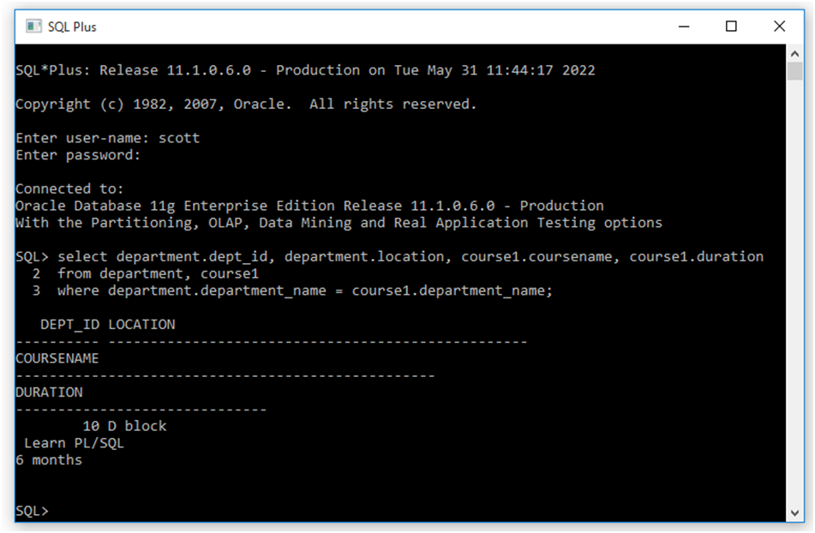

2. Non-equijoin :- The nonequijoins is such a join which match column values from different tables based on an inequality (instead of the equal sign like >, <, >=, <= ) expression. The value of the join column in each row in the source table is compared to the corresponding values in the target table. A match is found if the expression based on an inequality operator used in the join, evaluates to true.

3. Left Outer Join:- The Left Join keyword returns all records from the left table (table1), and the matching records from the right table (table2). The result is 0 records from the right side, if there is no match.

SYNTAX:- SELECT dept_id, location From department left outer join course1

ON department.department_name = course1.department_name;

OUTPUT:-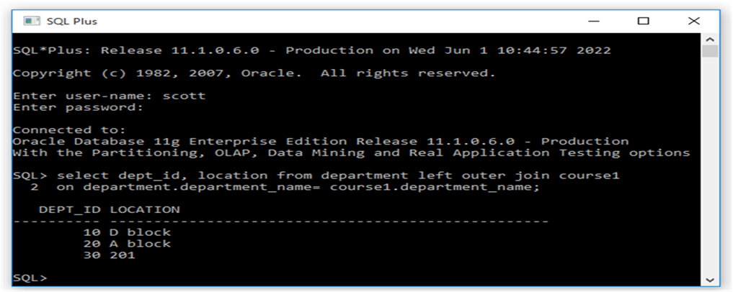

4.Right Outer Join:-The Right Join keyword returns all records from the right table (table2), and the matching records from the left table (table1). The result is 0 records from the left side, if there is no match.

SYNTAX:- SELECT dept_id, location From department right outer join course1

ON department.department_name = course1.department_name;

OUTPUT:-

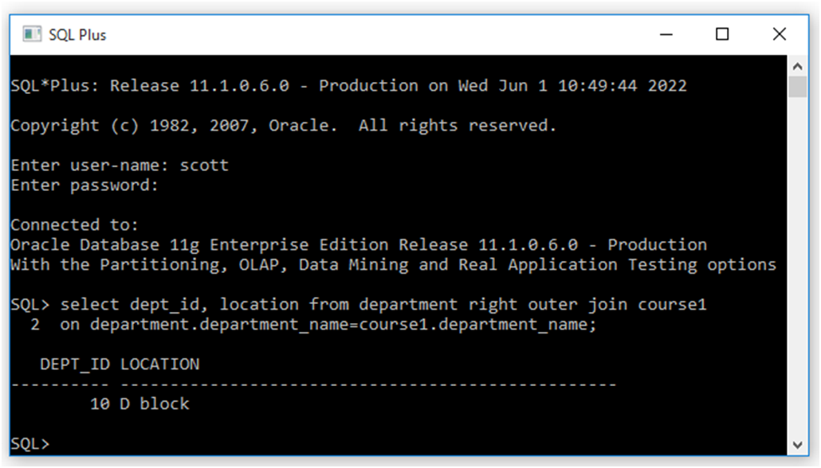

5.Full join:- The Full Outer Join keyword returns all records when there is a match in left (table1) or right

(table2) table records

SYNTAX:- SELECT dept_id,location From department full outer join course1

ON department.department_name = course1.department_name;

OUTPUT:-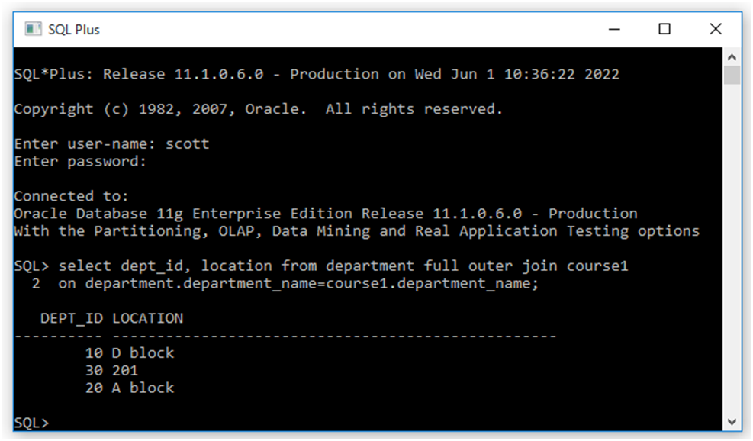

6.Self join:- A self join is a regular join, but the table is joined with itself.

SYNTAX;- course1.coursename, course1.duration

From department, course1

WHERE department.department_name = course1.department_name;

